**Kalinga University**

**Course- BCSAIML/BCAAIML Sem-IV  
Subject- Cloud Computing and its Security**

**Subject Code: BCAAIML402/BCSAIML403**

**UNIT-I**

**History of Cloud Computing**

In this, we will cover the basic overview of cloud computing. And you will see mainly our focus on history of cloud computing and will cover the history of client server computing, distributed computing, and cloud computing. Let’s discuss it one by one.

[**Cloud Computing**](https://www.geeksforgeeks.org/cloud-computing/)**:**

Cloud Computing referred as the accessing and storing of data and provide services related to computing over the internet. It simply referred as it remote services on the internet manage and access data online rather than any local drives. The data can be anything like images, videos, audios, documents, files etc.

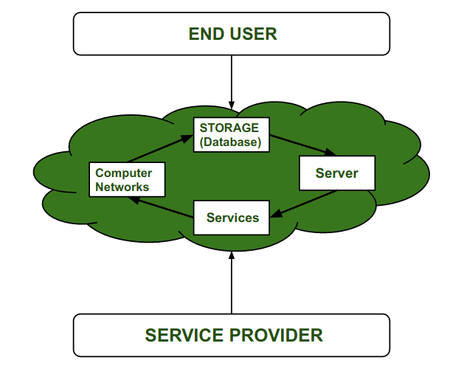

**Cloud Computing Service Provider’s :**  
Cloud computing is in huge demand so, big organization providing the service like[Amazon AWS](https://www.geeksforgeeks.org/introduction-to-amazon-web-services/), [Microsoft Azure](https://www.geeksforgeeks.org/introduction-microsoft-azure-cloud-computing-service/), [Google Cloud](https://www.geeksforgeeks.org/what-is-google-cloud-platform-gcp/), [Alibaba cloud](https://www.geeksforgeeks.org/difference-between-alibaba-cloud-tsdb-and-amazon-documentdb/) etc. are some Cloud Computing service Provider.

**History of Cloud Computing :**  
In this, we will discuss the history of Cloud computing. And also cover the history of client server computing, distributed computing, and cloud computing.

* Before Computing was come into existence, client Server Architecture was used where all the data and control of client resides in Server side. If a single user want to access some data, firstly user need to connect to the server and after that user will get appropriate access. But it has many disadvantages. So, After Client Server computing, Distributed Computing was come into existence, in this type of computing all computers are networked together with the help of this, user can share their resources when needed. It also has certain limitations. So in order to remove limitations faced in distributed system, cloud computing was emerged.

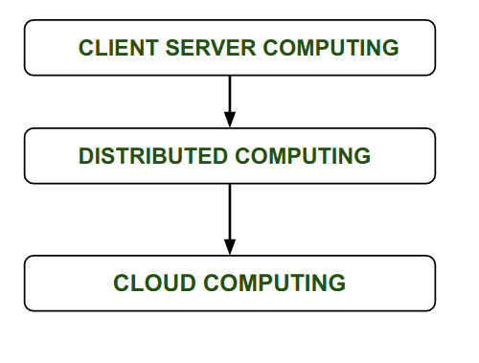

* During 1961, John MacCharty delivered his speech at MIT that “Computing Can be sold as a Utility, like Water and Electricity.” According to John MacCharty it was a brilliant idea. But people at that time don’t want to adopt this technology. They thought the technology they are using efficient enough for them.  So, this concept of computing was not appreciated much so and very less will research on it. But as the time fleet the technology caught the idea after few years this idea is implemented. So, this is implemented by Salesforce.com in 1999.
* This company started delivering an enterprise application over the internet and this way the boom of Cloud Computing was started.
* In 2002, Amazon started Amazon Web Services (AWS), Amazon will provide storage, computation over the internet. In 2006 Amazon will launch Elastic Compute Cloud Commercial Service which is open for Everybody to use.
* After that in 2009, Google Play also started providing Cloud Computing Enterprise Application as other companies will see the emergence of cloud Computing they also started providing their cloud services. Thus, in 2009, Microsoft launch Microsoft Azure and after that other companies like Alibaba, IBM, Oracle, HP also introduces their Cloud Services. In today the Cloud Computing become very popular and important skill.

**Advantages:**

* It is easier to get back up in cloud.
* It allows us easy and quick access stored information anywhere and anytime.
* It allows us to access data via mobile.
* It reduces both hardware and Software cost, and it is easily maintainable.
* One of the biggest advantages of Cloud Computing is Database Security.

**Disadvantages:**

* It requires good internet connection.
* User have limited control on the data.

**What is Cloud Computing?**

**Cloud Computing** means storing and accessing the data and programs on remote servers that are hosted on the internet instead of the computer’s hard drive or local server. Cloud computing is also referred to as Internet-based computing, it is a technology where the resource is provided as a service through the Internet to the user. The data that is stored can be files, images, documents, or any other storable document. Transparency, scalability, security and intelligent monitoring are some of the most important constraints which every cloud infrastructure should experience. Current research on other important constraints is helping cloud computing system to come up with new features and strategies with a great capability of providing more advanced cloud solutions.

To learn more about cloud architecture and its implementation, [the System Design Course](https://gfgcdn.com/tu/S3a/) delves into the core concepts, offering practical knowledge on how to design and deploy cloud-based systems.

**Cloud Computing Architecture**

Architecture of cloud computing is the combination of both [SOA (Service Oriented Architecture)](https://www.geeksforgeeks.org/service-oriented-architecture/) and EDA (Event Driven Architecture). Client infrastructure, application, service, runtime cloud, storage, infrastructure, management and security all these are the components of cloud computing architecture.

The cloud architecture is divided into 2 parts, i.e.

1. Frontend
2. Backend

The below figure represents an internal architectural view of cloud computing.

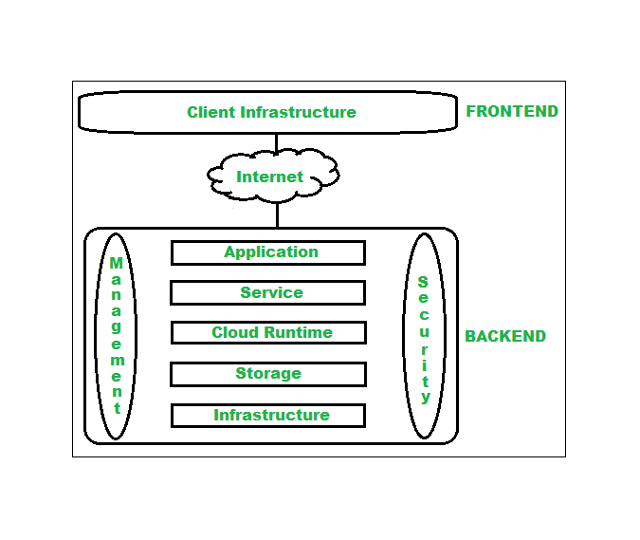

*Architecture of Cloud Computing*

**1. Frontend**

Frontend of the cloud architecture refers to the client side of cloud computing system. Means it contains all the user interfaces and applications which are used by the client to access the cloud computing services/resources. For example, use of a web browser to access the cloud platform.

**2. Backend**

Backend refers to the cloud itself which is used by the service provider. It contains the resources as well as manages the resources and provides security mechanisms. Along with this, it includes huge storage, virtual applications, virtual machines, traffic control mechanisms, deployment models, etc.

**Components of Cloud Computing Architecture**

Following are the components of Cloud Computing Architecture

1. **Client Infrastructure –** Client Infrastructure is a part of the frontend component. It contains the applications and user interfaces which are required to access the cloud platform. In other words, it provides a GUI( Graphical User Interface ) to interact with the cloud.
2. **Application**: Application is a part of backend component that refers to a software or platform to which client accesses. Means it provides the service in backend as per the client requirement.
3. **Service**: Service in backend refers to the major three types of cloud based services like [SaaS, PaaS and IaaS](https://www.geeksforgeeks.org/cloud-based-services/). Also manages which type of service the user accesses.
4. **Runtime Cloud**: Runtime cloud in backend provides the execution and Runtime platform/environment to the Virtual machine.
5. **Storage:**Storage in backend provides flexible and scalable storage service and management of stored data.
6. **Infrastructure:**Cloud Infrastructure in backend refers to the hardware and software components of cloud like it includes servers, storage, network devices, virtualization software etc.
7. **Management:**Management in backend refers to management of backend components like application, service, runtime cloud, storage, infrastructure, and other security mechanisms etc.
8. **Security:**Security in backend refers to implementation of different security mechanisms in the backend for secure cloud resources, systems, files, and infrastructure to end-users.
9. **Internet:**Internet connection acts as the medium or a bridge between frontend and backend and establishes the interaction and communication between frontend and backend.
10. **Database:** Database in backend refers to provide database for storing structured data, such as SQL and NOSQL databases. Example of Databases services include Amazon RDS, Microsoft Azure SQL database and Google CLoud SQL.
11. **Networking:**Networking in backend services that provide networking infrastructure for application in the cloud, such as load balancing, DNS and virtual private networks.
12. **Analytics:**Analytics in backend service that provides analytics capabilities for data in the cloud, such as warehousing, business intelligence and machine learning.

**Benefits of Cloud Computing Architecture**

* Makes overall cloud computing system simpler.
* Improves data processing requirements.
* Helps in providing high security.
* Makes it more modularized.
* Results in better disaster recovery.
* Gives good user accessibility.
* Reduces IT operating costs.
* Provides high level reliability.
* Scalability.

**Conclusion**

Cloud Computing architecture provides a structural framework for designing, implementing and managing cloud-based solutions. Cloud Computing Architecture provides benefits like scalability, flexibility, and cost-effectiveness. It also solve related to security, reliability, and performance.

**What is cloud storage?**

Cloud storage is a cloud computing model that enables storing data and files on the internet through a cloud computing provider that you access either through the public internet or a dedicated private network connection. The provider securely stores, manages, and maintains the storage servers, infrastructure, and network to ensure you have access to the data when you need it at virtually unlimited scale, and with elastic capacity. Cloud storage removes the need to buy and manage your own data storage infrastructure, giving you agility, scalability, and durability, with anytime, anywhere data access.

**Why is cloud storage important?**

Cloud storage delivers cost-effective, scalable storage. You no longer need to worry about running out of capacity, maintaining storage area networks (SANs), replacing failed devices, adding infrastructure to scale up with demand, or operating underutilized hardware when demand decreases. Cloud storage is elastic, meaning you scale up and down with demand and pay only for what you use. It is a way for organizations to save data securely online so that it can be accessed anytime from any location by those with permission.

Whether you are a small business or a large enterprise, cloud storage can deliver the agility, cost savings, security, and simplicity to focus on your core business growth. For small businesses, you no longer have to worry about devoting valuable resources to manage storage yourself, and cloud storage gives you the ability to scale as the business grows.

For large enterprises with billions of files and petabytes of data, you can rely on the scalability, durability, and cost savings of cloud storage to create centralized data lakes to make your data accessible to all who need it.

**Cost effectiveness**

With cloud storage, there is no hardware to purchase, no storage to provision, and no extra capital being used for business spikes. You can add or remove storage capacity on demand, quickly change performance and retention characteristics, and only pay for storage that you actually use. As data becomes infrequently and rarely accessed, you can even automatically move it to lower-cost storage, thus creating even more cost savings. By moving storage workloads from on premises to the cloud, you can reduce total cost of ownership by removing overprovisioning and the cost of maintaining storage infrastructure.

**Increased agility**

With cloud storage, resources are only a click away. You reduce the time to make those resources available to your organization from weeks to just minutes. This results in a dramatic increase in agility for your organization. Your staff is largely freed from the tasks of procurement, installation, administration, and maintenance. And because cloud storage integrates with a wide range of analytics tools, your staff can now extract more insights from your data to fuel innovation.

**Faster deployment**

When development teams are ready to begin, infrastructure should never slow them down. [Cloud storage services](https://aws.amazon.com/products/storage/) allow IT to quickly deliver the exact amount of storage needed, whenever and wherever it's needed. Your developers can focus on solving complex application problems instead of having to manage storage systems.

**Efficient data management**

By using cloud storage lifecycle management policies, you can perform powerful information management tasks including automated tiering or locking down data in support of compliance requirements. You can also use cloud storage to create multi-region or global storage for your distributed teams by using tools such as replication. You can organize and manage your data in ways that support specific use cases, create cost efficiencies, enforce security, and meet compliance requirements.

**Virtually unlimited scalability**

Cloud storage delivers virtually unlimited storage capacity, allowing you to scale up as much and as quickly as you need. This removes the constraints of on-premises storage capacity. You can efficiently scale cloud storage up and down as required for analytics, data lakes, backups, or cloud native applications. Users can access storage from anywhere, at any time, without worrying about complex storage allocation processes, or waiting for new hardware.

**Business continuity**

Cloud storage providers store your data in highly secure data centers, protecting your data and ensuring business continuity. Cloud storage services are designed to handle concurrent device failure by quickly detecting and repairing any lost redundancy. You can further protect your data by using versioning and replication tools to more easily recover from both unintended user actions or application failures.

With cloud storage services, you can:

* Cost-effectively protect data in the cloud without sacrificing performance.
* Scale up your backup resources in minutes as data requirements change.
* Protect backups with a data centre and network architecture built for security-sensitive organizations.

**How does cloud storage work?**

Cloud storage is delivered by a cloud services provider that owns and operates data storage capacity by maintaining large datacentres in multiple locations around the world. Cloud storage providers manage capacity, security, and durability to make data accessible to your applications over the internet in a pay-as-you-go model. Typically, you connect to the storage cloud either through the internet or through a dedicated private connection, using a web portal, website, or a mobile app. When customers purchase cloud storage from a service provider, they turn over most aspects of the data storage to the vendor, including capacity, security, data availability, storage servers and computing resources, and network data delivery. Your applications access cloud storage through traditional storage protocols or directly using an application programming interface (API). The cloud storage provider might also offer services designed to help collect, manage, secure, and analyse data at a massive scale.

**What are the types of cloud storage?**

There are three main cloud storage types: object storage, file storage, and block storage. Each offers its own advantages and has its own use cases.

**Object storage**

Organizations have to store a massive and growing amount of unstructured data, such as photos, videos, [machine learning (ML)](https://aws.amazon.com/what-is/machine-learning/), sensor data, audio files, and other types of web content, and finding scalable, efficient, and affordable ways to store them can be a challenge. Object storage is a data storage architecture for large stores of unstructured data. Objects store data in the format it arrives in and makes it possible to customize metadata in ways that make the data easier to access and analyze. Instead of being organized in files or folder hierarchies, objects are kept in secure buckets that deliver virtually unlimited scalability. It is also less costly to store large data volumes.

Applications developed in the cloud often take advantage of the vast scalability and metadata characteristics of object storage.[Object storage solutions](https://aws.amazon.com/what-is-cloud-object-storage/) are ideal for building modern applications from scratch that require scale and flexibility, and can also be used to import existing data stores for analytics, backup, or archive.

**File storage**

File-based storage or file storage is widely used among applications and stores data in a hierarchical folder and file format. This type of storage is often known as a network-attached storage (NAS) server with common file level protocols of Server Message Block (SMB) used in Windows instances and Network File System (NFS) found in Linux.

**Block storage**

Enterprise applications like databases or enterprise resource planning (ERP) systems often require dedicated, low-latency storage for each host. This is analogous to direct-attached storage (DAS) or a storage area network (SAN). In this case, you can use a cloud storage service that stores data in the form of blocks. Each block has its own unique identifier for quick storage and retrieval.

What cloud storage requirements should you consider?

Ensuring your company’s critical data is safe, secure, and available when needed is essential. There are several fundamental requirements when considering storing data in the cloud.

**Durability and availability**

Cloud storage simplifies and enhances traditional data center practices around data durability and availability. With cloud storage, data is redundantly stored on multiple devices across one or more data centers.

**Security**

With cloud storage, you control where your data is stored, who can access it, and what resources your organization is consuming at any given moment. Ideally, all data is encrypted, both at rest and in transit. Permissions and access controls should work just as well in the cloud as they do for on-premises storage.

**Why It Matters: Cloud Computing**

Cloud computing allows users to use computer applications, store files, and communicate and collaborate with others using the internet instead of a local server. The word “cloud” is used as a metaphor because the data is not stored locally and is transferred over the internet. Many cloud computing applications are free to use, though some require a subscription fee. Cloud computing applications are widely used and will likely be important to you and your organization.

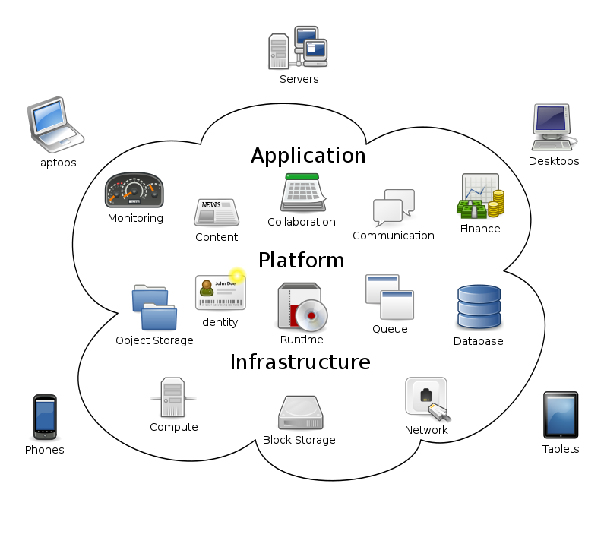

Cloud computing applications can typically be accessed in one of two different ways:

1. using your web browser on your computer or phone
2. using applications downloaded to your device that sync to the web

There are many different cloud computing applications. In this module, we will learn about email, calendars, instant messaging, video conferencing, and cloud storage applications.

Advantages and Disadvantages of Cloud Computing

Here, we are going to discuss some important advantages of Cloud Computing-

Advantages:

Business operations are being transformed by the transformational technology known as cloud computing. With its extensive advantages and possibilities, cloud computing has emerged as a crucial strategic tool for businesses in a range of sectors. Businesses can take advantage of various benefits that promote development, innovation, and operational effectiveness by leveraging the power of the cloud.

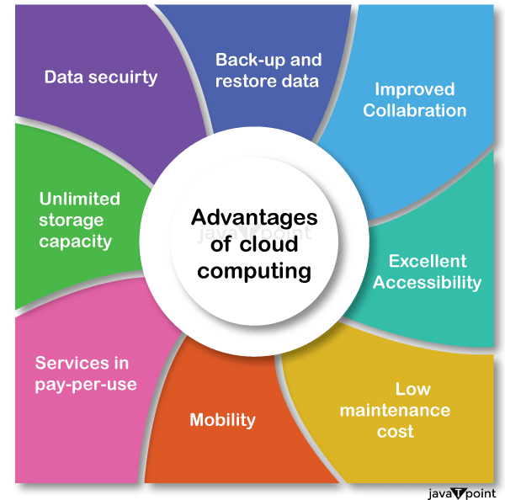

Let's explore the advantages that cloud computing has to offer:

**Data Backup and Restoration:**

Cloud computing offers a quick and easy method for data backup and restoration. Businesses may simply access and restore their data in the event of any data loss or system failure by keeping it in the cloud.

**Improved Collaboration:**

Collaboration is improved because cloud technologies make it possible for teams to share information easily. Multiple users may work together on documents, projects, and data thanks to shared storage in the cloud, enhancing productivity and teamwork.

**Excellent Accessibility:**

Access to information stored in the cloud is made possible. Users can access their data from anywhere in the world with an internet connection, making remote work, flexibility, and effective operations possible.

**Cost-effective Maintenance:**

Advertisement

Organizations using cloud computing can save money on both hardware and software upkeep. Because cloud service providers manage the maintenance and updates, businesses no longer need to make costly infrastructure investments or set aside resources for continuous maintenance.

**Upkeep and Updates:**

Cloud service providers take care of infrastructure upkeep, security patches, and updates, freeing organizations from having to handle these duties themselves.

This frees up IT teams' time and resources to work on higher-value projects like application development, data analysis, or strategic initiatives rather than wasting them on rote upkeep and updates.

**Mobility:**

Cloud computing makes it simple for mobile devices to access data. Utilizing smartphones and tablets, users can easily access and control their cloud-based applications and data, increasing their mobility and productivity.

**Pay-per-use Model:**

Cloud computing uses a pay-per-use business model that enables companies to only pay for the services they really utilize. This method is affordable, eliminates the need for up-front investments, and offers budget management flexibility for IT.

**Scalable Storage Capacity:**

Businesses can virtually store and manage a limitless amount of data in the cloud. The cloud offers a scalable and centralized storage option for all types of data, including documents, photos, audio, video, and other kinds of files.

**Enhanced Data Security:**

Cloud computing places a high focus on data security. To guarantee that data is handled and stored safely, cloud service providers offer cutting-edge security features like encryption, access limits, and regular security audits. Businesses can rest easy knowing that their important data is secure.

**Disaster Recovery and Business Continuity:**

Cloud computing provides reliable options for these two issues. Businesses can quickly bounce back from any unforeseen disasters or disruptions thanks to data redundancy, backup systems, and geographically dispersed data centers.

**Agility and Innovation:**

Businesses can continue to be innovative and nimble thanks to cloud computing. Organizations may quickly embrace new solutions, test out emerging trends, and promote corporate growth with access to a variety of cloud-based tools, services, and technology.

**Green Computing:**

By maximizing the use of computer resources, lowering energy use, and minimizing e-waste, cloud computing may support environmental sustainability.

By utilizing technologies like virtualization and load balancing to maximize the use of computer resources, cloud providers can operate large-scale data centers built for energy efficiency, resulting in lower energy usage and a smaller carbon footprint.

These benefits of cloud computing give companies the ability to use cutting-edge technology offered by cloud service providers while maximizing productivity, cost savings, scalability, and data security. They also enable them to concentrate on their core capabilities.

Disadvantages of Cloud Computing

When we talk about the "disadvantages of cloud computing," we're talking about any potential drawbacks or difficulties that businesses might have when utilizing cloud computing services. These drawbacks draw attention to some restrictions or risks related to cloud computing that businesses should take into account before making a choice.

Some of the Disadvantages of Cloud Computing are as follows:

* **Vendor Reliability and Downtime:**

Because of technological difficulties, maintenance needs, or even cyberattacks, cloud service providers can face outages or downtime. Users may not be able to access their data or applications during these times, which can interfere with business operations and productivity.

* **Internet Dependency:**

A dependable and fast internet connection is essential for cloud computing. Business operations may be delayed or interrupted if there are connectivity problems or interruptions in the internet service that affect access to cloud services and data.

* **Limited Control and Customization:**

Using standardized services and platforms offered by the cloud service provider is a common part of cloud computing. As a result, organizations may have less ability to customize and control their infrastructure, applications, and security measures. It may be difficult for some organizations to modify cloud services to precisely match their needs if they have special requirements or compliance requirements.

* **Data Security and Concerns about Privacy:**

Concerns about data security and privacy arise when sensitive data is stored on the cloud. Businesses must have faith in the cloud service provider's security procedures, data encryption, access controls, and regulatory compliance. Unauthorized access to data or data breaches can have serious repercussions, including financial loss, reputational harm, and legal obligations.

* **Hidden Costs and Pricing Models:**

Although pay-as-you-go models and lower upfront costs make cloud computing more affordable, businesses should be wary of hidden charges. Data transfer fees, additional storage costs, fees for specialized support or technical assistance, and expenses related to regulatory compliance are a few examples.

* **Dependency on Service Provider:**

When an organization depends on a cloud service provider, it is dependent on that provider's dependability, financial security, and longevity. Users may have disruptions and difficulties switching to alternate options if the provider runs into financial difficulties, changes their pricing policy, or even closes down their services.

* **Data Location and Compliance:**

When data is stored in the cloud, it frequently sits in numerous data centers around the globe that may be governed by multiple legal systems and data protection laws. This may pose compliance issues, especially if some sectors of the economy or nations have stringent data sovereignty laws.

Organizations should carry out a comprehensive risk assessment, thoroughly examine the dependability and security procedures of possible cloud service providers, and build backup and disaster recovery strategies to counteract these drawbacks.

**Top 10 Cloud Platform Service Providers in 2024**

Cloud Computing has revolutionized IT solutions, replacing traditional hard drive storage with accessible services delivered over the Internet. From storage to **processing,** **networking,**and**software, cloud computing**offers a range of solutions. Whether updating **social media** or **banking online**, chances are, cloud computing is involved. Many businesses invest heavily in cloud migration to address challenges and stay competitive.

*“Cloud is the new electricity. Every business will become a software business, build applications, use advanced analytics, and provide SaaS services.”*

***–Satya Nadella***

***Top 10 Cloud Platform Service Providers in 2024***

In 2024, it’s really important to know about the top 10 cloud platform service providers. Companies like Amazon Web Services ([AWS](https://www.geeksforgeeks.org/aws-tutorial/)), [Microsoft Azure](https://www.geeksforgeeks.org/introduction-microsoft-azure-cloud-computing-service/), and Google Cloud Platform ([GCP](https://www.geeksforgeeks.org/google-cloud-platform-tutorial/)) are leading the pack. They offer a wide range of services that help businesses be more creative and grow. Using cloud technology is a smart move for any business wanting to stay ahead in today’s digital world. If businesses don’t keep up with this technology, they risk falling behind.

*Try* [***Kamatera***](https://go.cloudwm.com/visit/?bta=36097&nci=5676&afp=premium)*-a top cloud platform service provider in 2024, known for its flexibility, scalability, and cost efficiency. Offering customizable cloud infrastructure, including VPS and cloud storage, Kamatera allows real-time adjustments to server configurations for optimal performance. Its global data centers ensure low latency and high availability, backed by a* ***99.95% uptime guarantee****. With advanced security features and* ***24/7 technical support,*** *Kamatera is a reliable choice for modern businesses.*

**List of Top 10 Cloud Platform Service Providers in 2024**

Certainly! Here are the **Top Cloud Service Providers** for the year 2024:

**Table of Content**

* [List of Top 10 Cloud Platform Service Providers in 2024](https://www.geeksforgeeks.org/top-cloud-platform-service-providers/#list-of-top-10-cloud-platform-service-providers-in-2024)
* [1. Amazon Web Services (AWS)](https://www.geeksforgeeks.org/top-cloud-platform-service-providers/#1-amazon-web-services-aws)
* [2. Microsoft Azure](https://www.geeksforgeeks.org/top-cloud-platform-service-providers/#2-microsoft-azure)
* [3. Kamatera](https://www.geeksforgeeks.org/top-cloud-platform-service-providers/#3-google-cloud-platform-gcp)
* [4. Alibaba Cloud](https://www.geeksforgeeks.org/top-cloud-platform-service-providers/#4-alibaba-cloud)
* [5. Oracle Cloud](https://www.geeksforgeeks.org/top-cloud-platform-service-providers/#5-oracle-cloud)
* [6. IBM Cloud (Kyndryl)](https://www.geeksforgeeks.org/top-cloud-platform-service-providers/#6-ibm-cloud-kyndryl)
* [7. Tencent Cloud](https://www.geeksforgeeks.org/top-cloud-platform-service-providers/#7-tencent-cloud)
* [8. OVHcloud](https://www.geeksforgeeks.org/top-cloud-platform-service-providers/#8-ovhcloud)
* [9. DigitalOcean](https://www.geeksforgeeks.org/top-cloud-platform-service-providers/#9-digitalocean)
* [10. Linode (owned by Akamai)](https://www.geeksforgeeks.org/top-cloud-platform-service-providers/#10-linodeowned-by-akamai)
* [Conclusion](https://www.geeksforgeeks.org/top-cloud-platform-service-providers/#conclusion)
* [Top 10 Cloud Platform Service Providers – FAQs](https://www.geeksforgeeks.org/top-cloud-platform-service-providers/#top-10-cloud-platform-service-providers-faqs)

**1. Amazon Web Services (AWS)**

Launched in 2006, AWS is the best cloud service provider **leading in the market**. It becomes a major player in AI, database, machine learning, 5G cloud, multi-cloud and serverless deployments. AWS operates in **20 geographical regions** across the world. The company reported a revenue of **9 billion dollars** in Q3 2019.

* AWS offers **175 fully-featured services** to meet any kind of business requirements. These services are database storage, computing power, networking and many more
* You can virtually host any applications, including networks like firewall, DNS, Load balancing, or even you can have your virtual private cloud.
* AWS applications are scalable, flexible, reliable, secure and trustworthy.
* Easy sign-up and fast deployment. The best thing is there is no upfront cost and you pay for what you use. It also offers a FREE tier for some of their popular services.

*Read more about AWS from the link* [*Top 10 Reasons to Learn AWS – Services And Benefits*](https://www.geeksforgeeks.org/top-10-reasons-to-learn-aws-services-and-benefits/)

**Top Companies using Amazon Web Services (AWS)**

* *Netflix*
* *Spotify*
* *Airbnb*
* *Uber*
* *Peloton*
* *Expedia*
* *Pinterest*
* *Samsung*
* *Sony*
* *Novartis*

**2. Microsoft Azure**

Microsoft Azure was launched in 2010 as Windows Azure, and later in 2014, it was renamed, Microsoft Azure. It was launched years after the release of AWS and Google cloud but still, it is the fastest-growing cloud and giving tough competition to AWS and other cloud service providers. There is a five-year partnership between Microsoft and **Disney**. In this partnership, the new method will be developed to move production content to the cloud. Azure has **54 data centers** regions across the world available in **140 countries**.

**Top Companies using Microsoft Azure**

* *Walmart*
* *Macy’s*
* *The Home Depot*
* *Starbucks*
* *Coca-Cola*
* *Bank of America*
* *JPMorgan Chase*
* *Citigroup*
* *Fidelity Investments*
* *Standard Chartered*

**3. Kamatera**

[**Kamatera**](https://go.cloudwm.com/visit/?bta=36097&nci=5676&afp=review), established over two decades ago, has evolved into one of the most reliable and flexible cloud infrastructure platforms in the industry. With a strong focus on scalability, Kamatera allows businesses to configure their cloud environments based on real-time needs, making it a top choice for startups and large enterprises alike. Unlike many other providers, Kamatera’s pricing is incredibly cost effective, allowing users to pay only for the resources they use, with no hidden fees. The platform supports a wide array of operating systems and software, giving users complete freedom to build and deploy custom cloud solutions. In 2024, Kamatera is renowned for its global data centers that ensure minimal latency and high availability across the world.

**Top Companies using Kamatera**

* *Xero*
* *Redfin*
* *CivicFlus*
* *CoSchedule*
* *MarketMuse*
* *AirCail*
* *Veeqo*
* *Foirt of Rertal*
* *Raken*

**4. Alibaba Cloud**

Alibaba Cloud, also known as Aliyun, is the cloud computing arm of Alibaba Group, one of the world’s largest e-commerce and technology conglomerates based in China. It offers a comprehensive suite of cloud computing services to support businesses worldwide, including:

**Market Presence:**

* Currently holding the **third largest global market share** in cloud computing, following Amazon Web Services (AWS) and Microsoft Azure.
* **Dominates the Asian market**, particularly in China.

**Service Portfolio:**

* Offers a **diverse and comprehensive suite** of cloud solutions, including:
  + **Compute:** Elastic Compute Service (ECS) for virtual machines, Serverless Computing, Container Services.
  + **Storage:** Object Storage Service (OSS), File Storage Service (NAS), Block Storage Service (ESSD).
  + **Networking:** Virtual Private Cloud (VPC), Elastic Network Interface (ENI), Global Accelerator.
  + **Databases:** Alibaba Cloud Database Service (RDS), NoSQL databases, Graph Database.
  + **AI & ML:** AI Platform, pre-trained models, Big Data Analytics.
  + **Security & Identity:** Security Center, Anti-DDoS, Key Management Service.
  + **Developer Tools:** API Gateway, Serverless Application Model (SAM), CodePipeline.
  + **Industry-Specific Solutions:** Tailored solutions for retail, manufacturing, finance, and more.

**Top Companies using Alibaba Cloud**

* *ABS-CBN*
* *PrestoMall (formerly 11street Malaysia)*
* *Hang Seng Bank*
* *Chow Tai Fook Jewellery Group*

**5. Oracle Cloud**

Oracle Cloud is an **ERP(Enterprise Resource Planning)** based cloud service that helps you to build, deploy, and manage workloads in the cloud or on-premises. Oracle has approximately **4, 30, 000** huge numbers of clients around the world. The total revenue generated by Oracle was around **6.81 billion dollars** in 2019.

* Oracle IaaS offerings are Compute, Storage, Networking, Governance, Database, Load Balancing, DNS Monitoring, Ravello, and FastConnect.IaaS help to run any kind of workload of an Enterprise.
* Oracle PaaS offerings are Data Management, Application Development, Integration, Business Analytics, Security, Management, and Content and Enterprise. PaaS helps developers to develop, connect, secure and share data across the applications.
* Oracle SaaS offerings are CX, HCM, ERP, SCM, EPM, IoT, Analytics, Data, and Blockchain Applications. SaaS provides a complete data-driven and secure cloud environment.
* The best thing about this cloud services provider is its **chatbot**option which can help customers 24/7 whenever they face difficulties.
* Data analytics by users that help decision-makers in planning for the company’s financial condition.
* Secure and better visibility to unsanctioned apps and protects against sophisticated cyberattacks.
* Payment according to the usage.

**Top Companies using Oracle Cloud**

* *Labcorp*
* *Diebold Nixdorf*
* *CVS Health*
* *Universal Studios*
* *Zurich*
* *UnitedHealth Group*
* *Hitachi*
* *Ahold Delhaize*
* *Bank of America*

**6. IBM Cloud (Kyndryl)**

Developed by IBM, this cloud service offers another set of solutions to the users to deploy their applications on the cloud. It offers IaaS, SaaS, and PaaS services via **public, private, hybrid and multi-cloud** models. IBM generated **5.3 billion dollars** of revenues according to Q3 2019 which is 6.4 percent higher than the previous quarter. IBM cloud offers approximately 170 products and services to meet the customer’s business demands. IBM’s best bets come in the form of the **Internet of Things, Cognitive Computing and Blockchain**. Recently IBM has **Red Hat**, for the delivery of hybrid solutions efficiently. The cloud service is helping home appliance manufacturers, retailers, and medical supply businesses.

* Computer Network, Storage, Cloud Packs, Management, Security, Database, Analytics, AI, IoT, Mobile, Dev Tools, Blockchain, Integration, Migration, Private Cloud, and VMware are some services offered by IBM cloud.
* Freedom to select and unite the desired tools, data models and delivery models in designing/creating the next-generation services or applications.
* Users can manage their applications in many coding languages such as Java, Python, Swift, Php, etc.
* IBM AI helps with its multifunctional ability such as text to speech, detecting language, machine learning, classification of natural language, etc.
* Costs depends on the usage but free in its lite mode with free access to more than 40 services by IBM Cloud.
* You can incorporate **highly performing cloud communications and services** into your IT environment with the help of **IBM Bluemix** Cloud platform.

**Top Companies using IBM Cloud (Kyndryl)**

* ***City Furniture, Inc.***
* ***Chevron Phillips Chemical (CPChem)***
* ***Carrefour Belgium***
* ***Canadian Malartic***
* ***Bord Gáis Energy***
* ***Blue NAP Americas***
* ***Bank of Ayudhya Public Company Ltd (Krungsri)***
* ***Arizona Department of Transportation***

**7. Tencent Cloud**

**DigitalOcean** is a well-known cloud hosting provider that currently holds the **fourth largest global market share** in cloud computing, following Alibaba Cloud, AWS, and Microsoft Azure. It Has a **strong presence in China and Southeast Asia**, with growing international reach.

**Service Portfolio:**

* Offers a **comprehensive range of cloud solutions**, including:
  + **Compute:** **Cloud Virtual Machines (CVM)** for traditional VMs,**Serverless Functions (SCF)** for serverless computing, and Container Orchestration (TKE) for managing containerized applications.
  + **Storage:** Cloud Object Storage (COS) for highly scalable object storage, Cloud Block Storage (CBS) for high-performance block storage, and Cloud File Storage (CFS) for network-attached storage.
  + **Networking:** **Cloud Virtual Private Cloud (VPC)** for creating isolated virtual networks, Cloud Private Line (CPL) for dedicated connections, and Global Transit Gateway (GTW) for managing complex network environments.
  + **Databases:** **Cloud Database Service (TDSQL)** for managed databases, various managed NoSQL databases, and Data Aggregation Storage (DAS) for big data analytics.
  + **AI & ML:** Tencent AI Platform provides tools for building, training, and deploying AI models, and offers pre-trained models for various tasks.
  + **Security & Identity:** Cloud Security (Tencent Cloud Security) offers various security solutions, including **Anti-DDoS protection, Web Application Firewall (WAF**), and **Key Management Service (KMS).**
  + **Developer Tools:** API Gateway for managing APIs, Serverless Application Model (SAM) for developing serverless applications, and Cloud Code for integrated development and deployment.
  + **Industry-Specific Solutions:** Tailored solutions for gaming, media, healthcare, finance, and more.
* Known for its **expertise in gaming and media industry solutions**, leveraging the experience of its parent company, Tencent.
* Has a strong focus on **AI and machine learning**, offering a diverse range of AI tools and pre-trained models.
* Offers **competitive pricing with various flexible payment options**, including pay-as-you-go and reserved instances.

**Top Companies using Tencent Cloud**

* ***ChangYou***
* ***SINA Corporation***
* ***OS – Learning Fun***
* ***Q-See***
* ***NBA Media Ventures, LLC***

**8. OVHcloud**

**DigitalOcean** is a well-known cloud hosting provider that currently holds the **sixth largest global market share** in cloud computing, following Alibaba Cloud, AWS, Microsoft Azure, Tencent Cloud, and Google Cloud Platform. Known as a **strong player in Europe**, particularly in France, and is expanding its global presence.

**Service Portfolio:**

* Offers a **diverse range of cloud solutions**, including:
  + **Compute:** Dedicated servers (bare metal), Public Cloud with various VM options, Web Hosting solutions, and Private Cloud for on-premises infrastructure.
  + **Storage:** Dedicated storage solutions, Public Cloud Object Storage, Backup solutions, and High Availability storage.
  + **Networking:** Dedicated network solutions, Public Cloud Virtual Private Cloud (vRack), and managed network services.
  + **Databases:** Managed database solutions for various engines like MySQL, PostgreSQL, and MongoDB.
  + **AI & ML:** AI Marketplace with pre-trained models and solutions, and access to various AI and ML frameworks.
  + **Security & Identity:** Security solutions for various needs, including anti-DDoS protection, web application firewall, and vulnerability management.
  + **Developer Tools:** Various DevOps tools, API Gateway, and code repositories.
  + **Industry-Specific Solutions:**Tailored solutions for healthcare, media, e-commerce, and more.
* Known for its expertise in bare metal server solutions, offering high performance and customization.
* Has a strong commitment to data privacy and security, compliant with various European regulations.
* Places emphasis on open-source technologies and partnerships.
* Offers transparent and competitive pricing with various flexible options, including pay-as-you-go and commitment plans.

**Top Companies using OVHcloud**

* ***Emisora Escuela M21 Radio***
* ***H&R Block, Inc***
* ***Collège Boréal***
* ***VMware Inc***
* ***VMware Tanzu Observability***

**9. DigitalOcean**

**DigitalOcean** is a well-known cloud hosting provider that primarily caters to **startups, small and medium-sized businesses (SMBs), and individual developers**, holding a smaller market share compared to larger cloud providers. Known for its **strong presence in developer communities**.

**Service Portfolio:**

* Offers a **focused set of essential cloud solutions**, including:
  + **Compute:** Droplets (virtual machines) with various configurations and operating systems.
  + **Storage:** Block storage options for data persistence.
  + **Networking:** Private networking capabilities and additional networking add-ons.
  + **Databases:** Managed databases for popular engines like MySQL, PostgreSQL, and MariaDB.
  + **Containerization:** Managed Kubernetes platform for deploying containerized applications.
  + **App Platform:** Serverless platform for deploying web applications without managing infrastructure.
  + **Marketplace:** Additional tools and services from third-party partners.
* Prioritizes **simplicity and developer experience**, offering a user-friendly interface and APIs.
* Provides **transparent and predictable pricing**, making it cost-effective for smaller projects.
* Offers **extensive documentation and community support**, catering to developers’ needs.
* Operates on a **pay-as-you-go model** with clear pricing tiers based on resource usage.
* Offers **free tier for experimentation and learning**.

**Top Companies using DigitalOcean**

* *Shopify*
* *GitHub*
* *Airbnb*

**10. Linode (owned by Akamai)**

**Linode**, which is now part of **Akamai**, is a cloud platform primarily caters to **developers, startups, and SMBs**, holding a smaller market share compared to major cloud providers.Known for its **strong developer community and focus on simplicity**.

**What types of cloud services are available?**

The following are the three main types of [cloud computing](https://www.hpe.com/in/en/what-is/cloud-computing.html) services available. In each case, the service providers maintain the underlying [cloud infrastructure](https://www.hpe.com/in/en/what-is/cloud-infrastructure.html). Other computing resources can be handled by the provider or not, as required by the subscriber’s needs.

**Software as a Service (SaaS)**

Providers offer subscribers the use of their software running on a cloud infrastructure, which means the application can be widely distributed and accessed. Common types of business technologies hosted by the SaaS vendor include productivity suites, customer relationship management (CRM) software, human resources management (HRM) software, and data management software. Users have the option of accessing the application(s) through a program interface or a thin client interface, such as a web browser. With this service, subscribers are limited to access and use of the software only. The provider handles everything else: managing and controlling the network, servers, operating systems, storage, virtualization, data, middleware, and even individual application capabilities. SaaS apps are usually designed to be simple to use for a wider audience.

**Platform as a Service (PaaS)**

With PaaS, users have a bit more control than with SaaS because users gain access to a framework from the operating system up. PaaS allows users to place their own applications onto the cloud infrastructure with programming languages, libraries, services, and tools supported by the provider. The subscriber has control over the deployed applications, data, and possibly configuration settings for the application-hosting environment. But the network, servers, operating systems, and storage are managed and controlled by the provider.

**Infrastructure as a Service (IaaS)**

Using IaaS, subscribers can architect an entire environment by configuring a virtual network that is segmented from other networks. Within this environment, users run an operating system and provision the processing, storage, networks, and other fundamental computing resources needed to run software on the cloud infrastructure. With IaaS, the subscriber may also have limited control of select networking components (e.g., host firewalls). Some providers will also offer services such as monitoring, automation, security, load balancing, and storage resiliency.

**Anything as a Service (XaaS)**

There are several other service models defined as XaaS, which do not strictly fit in the above three categories. They are essentially anything as a service and are often limited to narrower offerings. Disaster Recovery as a Service, Communications as a Service, and Monitoring as a Service are good examples.

**What are the benefits of cloud services?**

* **Scalability**: Cloud services ensure optimal performance and cost-efficiency by providing the capacity to scale resources up or down in response to demand instantly.
* **Flexibility**: Businesses may more readily access and modify computer resources using cloud services, which increases their capacity to respond to business unit usage, shifting market circumstances and customer demands.
* **Processing Speed**: Private cloud systems operating model across your datacenters, colocation facilities or at the edge offer fast processing speeds that facilitate quick data analysis, application deployment, and productivity.
* **Security**: To guard against threats and breaches, cloud providers use strong security features, including encryption, access limits, and monitoring.
* **Cost Efficiency**: Pay-as-you-go pricing mechanisms and the absence of upfront hardware and infrastructure investments are two benefits of cloud services that make capital costs more efficient.
* Disaster Recovery: In the case of calamities or outages, cloud environments provide automatic backup, replication, and recovery procedures, guaranteeing data resilience and business continuity.
* **Agility**: Cloud services allow businesses to innovate and launch new services and apps swiftly, giving them a competitive edge and a quicker time to market.
* **Reliability**: Cloud providers ensure high availability and dependability for crucial business activities by providing redundant infrastructure and SLA-backed service assurances.